MATH 396 - Project

Trevor Dallow

April 17, 2017

x = c(-1, 1)  
plot(x, x, type ="l", xaxt = "n", yaxt = "n", xlab = "", ylab = "", main = "Octant Decomposition")  
lines(x, -x)  
lines(c(0, 0), x)  
lines(x, c(0, 0))

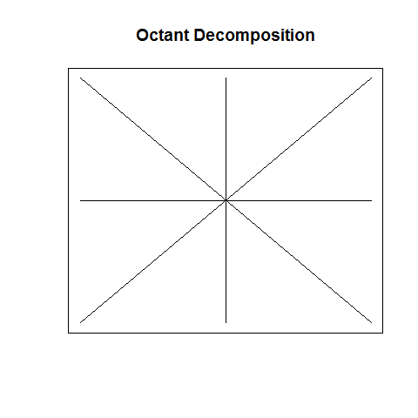

x = c(-1, 1)  
par(mfrow = c(4, 4), mar = rep(1, 4))  
for (i in 1:14) {  
 plot(x, x, type ="l", xaxt = "n", yaxt = "n", xlab = "", ylab = "", main = paste0("Octant Decomp. Case: ", as.roman(i)))  
 lines(x, -x)  
 lines(c(0, 0), x)  
 lines(x, c(0, 0))  
}

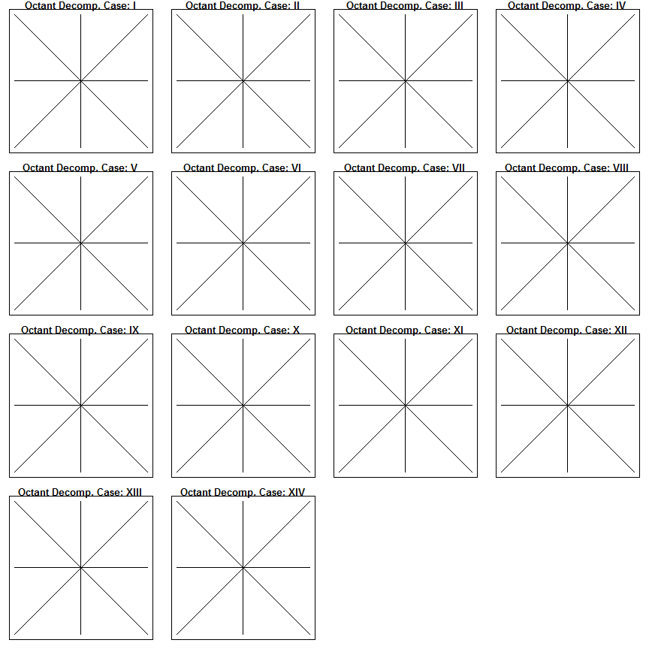

plot(x, x, type ="l", xaxt = "n", yaxt = "n", xlab = "", ylab = "", main = "Further Decomposition")  
lines(x, -x)  
lines(x, -2\*x)  
lines(x, -x/2)  
lines(c(0, 0), x)  
lines(x, c(0, 0))

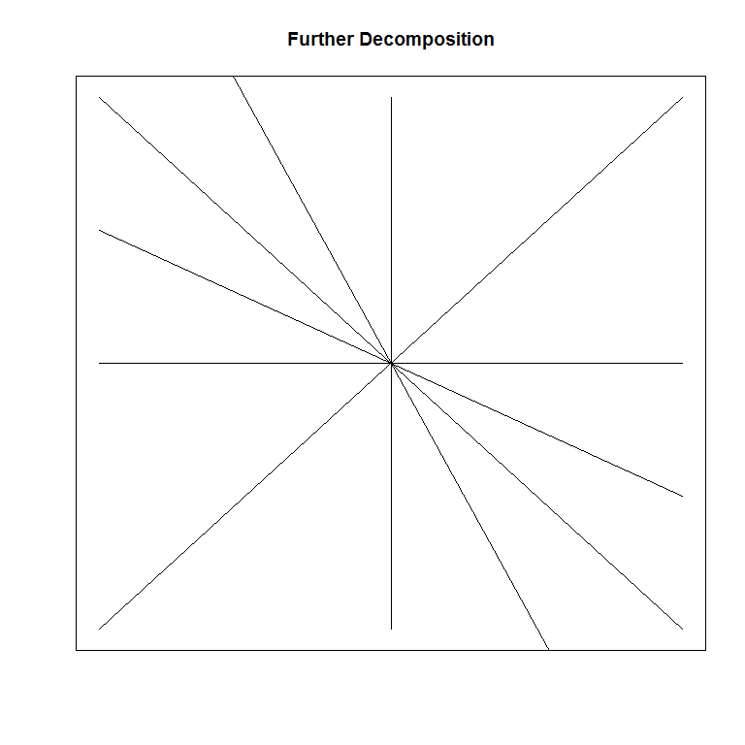

par(mfrow = c(4, 2), mar = rep(1, 4))  
for (i in 1:8) {  
 plot(x, x, type ="l", xaxt = "n", yaxt = "n", xlab = "", ylab = "", main = paste0("Further Decomp. Case: ", as.roman(i)))  
 lines(x, -x)  
 lines(x, -2\*x)  
 lines(x, -x/2)  
 lines(c(0, 0), x)  
 lines(x, c(0, 0))  
}

